Types of Stands
Linear

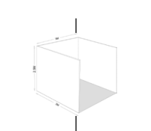 | Linear “In-Line” Stands – Linear stands are arranged in a straight line and will have a neighbouring stand on both the left and right side, sometimes backing onto another inline row. The standard height of 2.5m (8ft) is allowed along the back wall and each side.  You may display hanging signs, logos and graphics if they are set back 1.0 meters from any side, and you have gained permission from the Organiser. No advertising or logos should directly overlook any neighbouring stand.

